**Design document – User Management System**

**Overview**

This document is the complete analysis of the **web-based** Product Management System which will cover everything from the **purpose** of this application, **Tech stack** to see what are the technical requirements, **Data design** to see the flow of data across the application**,** and last but not the least working **user interface** of the application to see the final product.

**Purpose**

There are times when we have a bunch of users with **different authorities** in terms of the organization’s policies, this project is the starting point to **store the users** with their **basic information** in Phase 1 so that later we can add more details based on the requirements

**Tech stack**

To build an organized/sorted and configurable application we are following the **MVC architecture**

* **JSP:** Java Server Pages are used to create the **View** of the application i.e. the user interface from which the user can interact.
* **Servlets:** Another java web-based tech that will help in **Controlling** the application i.e. performing all the backend tasks done via Servlets
* **JDBC:** To handle the **Model/Data** part of MVC**,** we are using **JDBC API** to manage the database using JAVA**.**

**Functional Requirements**

There are some key requirements to fulfill the purpose of this application:

* **“Add” functionality:** To add new users, we should have the form in the front end for adding *new users*.
* **“Delete” functionality:** We should have the delete option along with each USER to delete the users who are now unauthorized to some services.
* **“Update” functionality:** Sometimes we might need to update the details of previous users, for that along with each product we should have an *update/edit option* as well.
* **“Show all products” functionality:** By this, we can see how many users are being added along with their complete details**.**

**Data Design**

* **User**

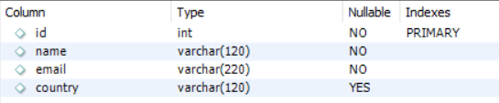

Above is the schema of the **“users”** table:

* **id:** The unique user id associated with each user that is added by the admin
* **name:** Name of the user
* **email:** Email of the user
* **country:** Country of the user from where he/she is associated with.

**Data Flow**



**User Interface**

**Home page:** The home page will itself have the form of **adding a new user**

**Fields-** User name, User Email, User Country

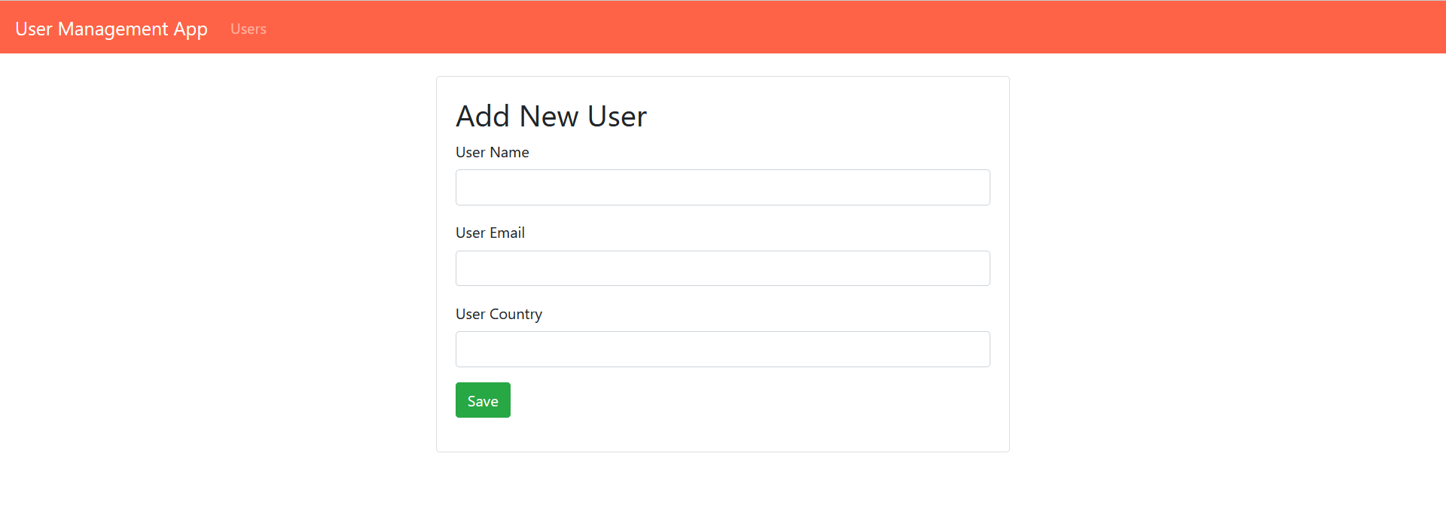

**All users page:** This page will show all the users that are saved in the database

* We can **edit** the details of existing users.
* We can **delete** unauthorized users.

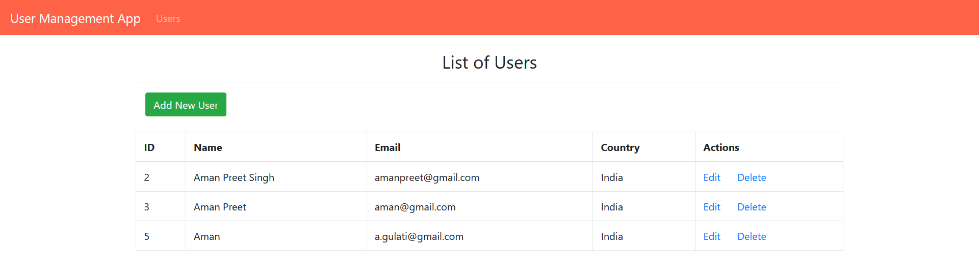

**Edit page:** On this page, we can **edit/update** the existing details of the user.

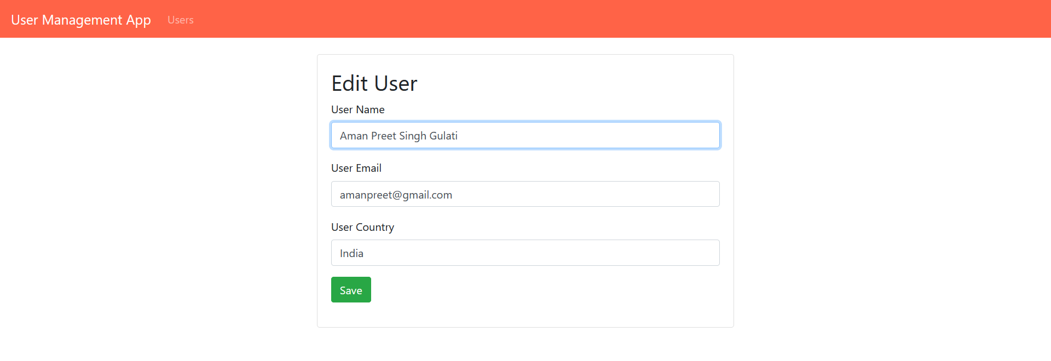

**Delete:** It will delete the user from the database and remove it from the **list of users** on the web page.

